**Experiment 2**

**Title: DML commands with constraints**

**Objective: -** To understand the concept of different DML commands.

1. Exercise on retrieving records from a table.

a. Find out the names of all the clients.

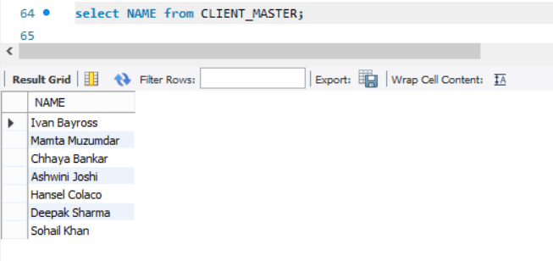

b. Retrieve the entire contents of the Client_Master table.

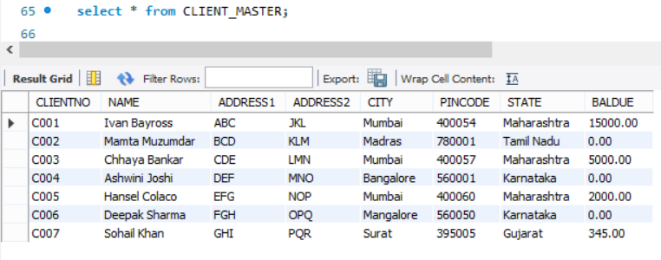

c. Retrieve the list of names,city and the state of all the clients.

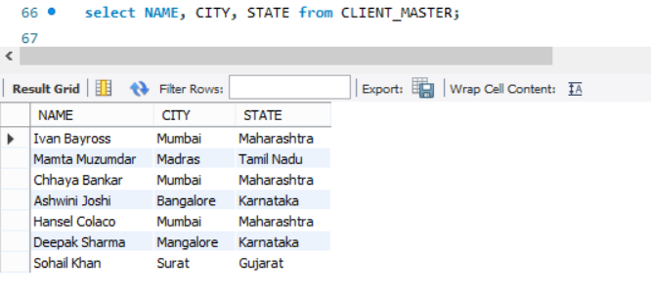

d. List the various products available from the Product_Master table.

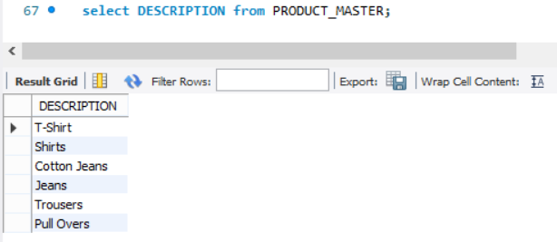

e. List all the clients who are located in Mumbai.  
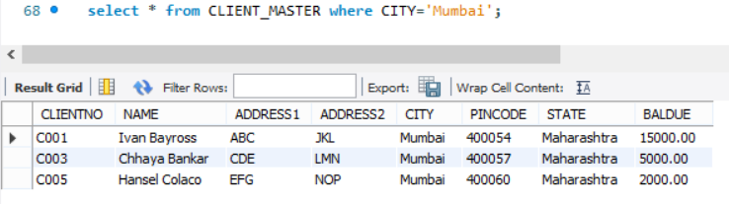

f. Find the names of salesman who have a salary equal to Rs.3000.

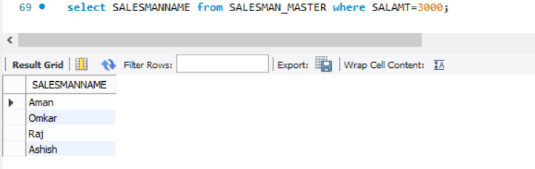

1. Exercise on updating records in a table

a. Change the city of ClientNo ‘C00005’ to ‘Bangalore’.

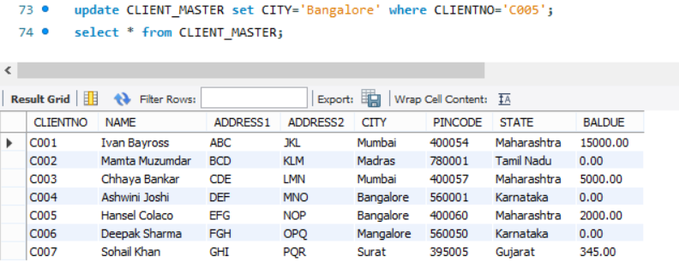

b. Change the BalDue of ClientNo ‘C00001’ to Rs.1000.

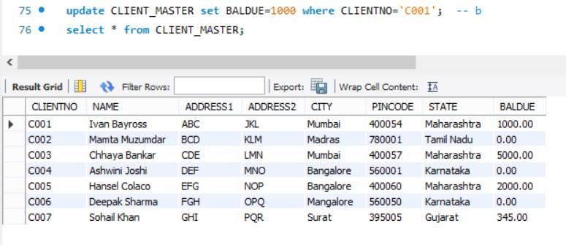

c. Change the cost price of ‘Trousers’ to rs.950.00.

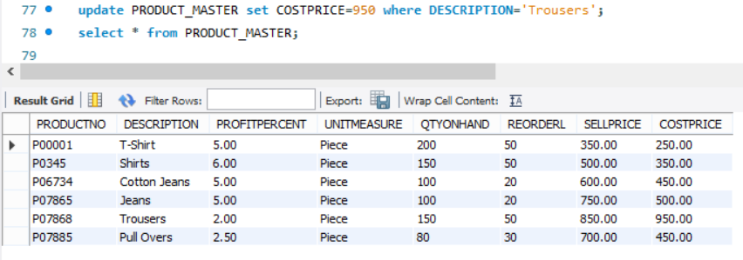

d. Change the city of the salesman to Pune.

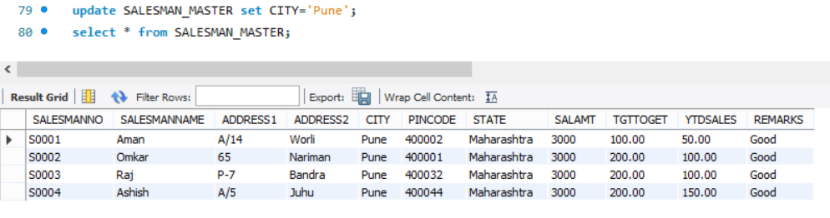

1. Exercise on deleting records in a table
2. Delete all salesman from the Salesman_Master whose salaries are equal to Rs.3500.

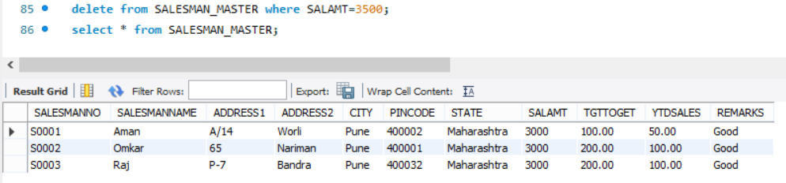

1. Delete all products from Product_Master where the quantity on hand is equal to 100.

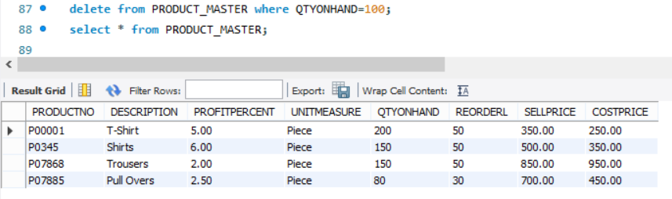

1. Delete from Client_Master where the column state holds the value ‘Tamil Nadu’.

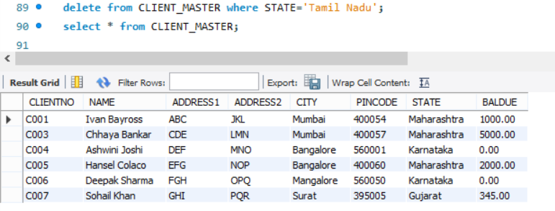

1. Exercise on altering the table structure

a. Add a column called ‘Telephone’ of data type integer to the Client_Master table.

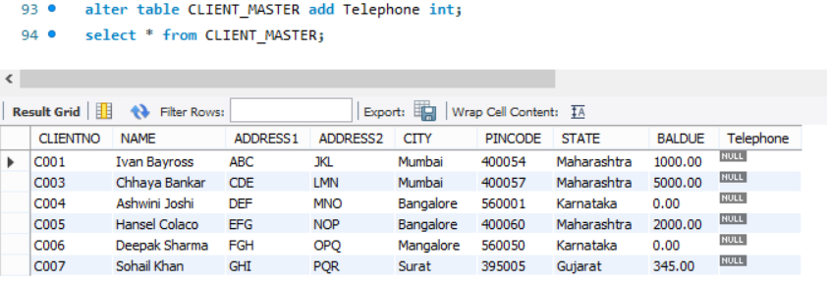

b. Change the size off SellPrice column in Product _Master to 10, 2.

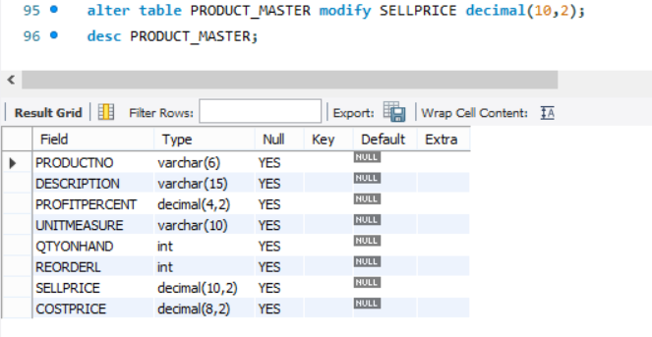

1. Exercise on deleting the table structure along with the data

a. Destroy the table Client_Master along with its data.

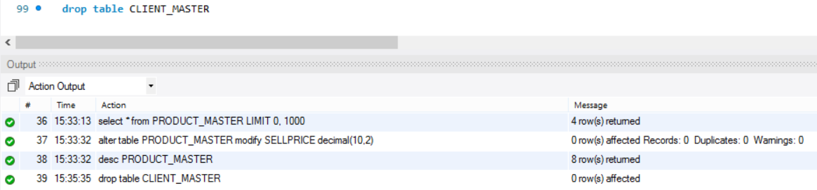

1. Exercise on renaming the table

a. Change the name of the Salesman_Master to sman_mast.

